YEAR 8 FLIGHT REVISION
Energy and Forces.

- State Bernoulli’s Law.

- Explain, using Bernoulli’s Law, how air flowing over the wing of an aeroplane creates lift. Use the diagram below

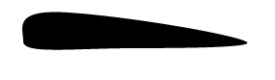

- Explain why a piece of paper left near the open window of a fast moving car will be sucked out.

- Explain, using Bernoulli’s Law, why smoke quickly rises up the chimney on a windy day but slowly on a day with no wind.

- What is FORCE?

- Complete the table below. Some are already completed for you.

 | What forces are acting on the object in question? | Are forces acting on the object balanced?
A plane flying at constant altitude and speed. | Drag, gravity, thrust and lift | Yes. Lift and gravity are balanced since the plane is flying at constant altitude. Drag and thrust are balanced since the plane is travelling at constant speed.
A plane accelerating down the runway about to take off.
A plane descending for landing.
A car travels at constant speed down the freeway.
A rocket sitting on the launch pad.
A hot air balloon floating at constant height above the ground
A hot air balloon rising at constant speed. | Gravity, buoyant force of air. | Yes. Since there is no change in the speed of the balloon gravity and buoyant force are balanced.
A car using its brakes to slow down. | Friction, gravity, drag.
A rocket accelerating skywards.
A swimmer floating on the surface of the water.
Meteor accelerating downwards through the air

- An air force cadet is asked to keep an eye on a plane travelling at constant speed and altitude. He is told to report to his senior officer the moment an external, unbalanced force appears to be acting on the plane.

Should he report a force?
The plane flies at constant speed and altitude.
The plane slowly changes direction.
The plane’s speed increases from 600.00km.hr to 601.00km/hr.
The plane’s altitude increases but its speed stays constant.
The speed of the plane changes but its altitude stays the same.
The plane changes color.
The plane’s fuselage changes shape.
The tail fin becomes slightly warped.
The pilot ejects an item from the cockpit.
A passenger moves about the cabin of the plane
Another passenger is seen to bounce off the wall of the plane.
- The formula to calculate force is given as F = ma. Where F = force, m = mass, and a = acceleration.
Using this formula, explain why there is no unbalanced force acting on an object if it is travelling at constant speed.

- State Newton’s 3rd Law of Motion and use it to explain how plane’s propeller generates the forward motion.

- A rock has a volume of 45cm³ and weighs 450 grams.
  - What is the density of the rock?
  - The rock is placed underwater and weighed. The electronic balance reading is much lower than 450 grams. What is the reading on the electronic balance if the density of water is 1g/cm³ ?
  - What is the mass of water pushing up on a 80 kg boy floating on the surface of the water.
  - What is the buoyant force acting on a boy floating on the surface of the water if the boy has a volume of 80,000 cm³.
  - Complete the table below. Assume the density of water is 1g/cm³. Do not indicate units.
 | Force acting down | Force acting up | Sink or float
A 200kg boat displaces 200 litres of water.
A 360 gram bucket of sand is placed in water and displaces 320 cm³ of water.
A 130 gram toy boat will float in the water. |  |  | Float
A 2,500,000 Kg hot air balloon displaces 2,500,000 Kg of cold air.

- Complete the table below. Select words from the following list.
  - Kinetic energy
  - Gravitational Potential Energy
  - Chemical Potential Energy.

Type of energy present
The rocket stands on the launch pad.
The rocket accelerates skyward.
The fuel is spent and the rocket is slowing down.
The rocket has reached its maximum height and is momentarily at rest.
The rock accelerated downwards.

- a) Explain why a rocket fuel must burn quickly and produce a great deal of heat and gas?

b) Compare the ways in which a rocket and a propeller plane produce thrust.

- Identify the forces acting on a rocket during launch. Indicate which forces are balanced or unbalanced.

The rocket stands on the launch pad. | 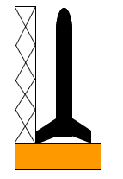
The rocket accelerates skyward. | 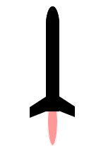
The rocket has spent its fuel and is slowing down. | 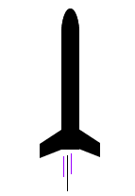
The rocket has reached its maximum height and is momentarily at rest. | 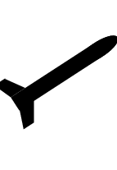
The rocket accelerates downward. | 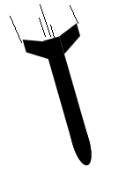
The parachute opens. | 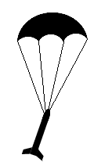

- The speed-time graph of a car is shown below. Indicate what the driver might be doing during the different time intervals
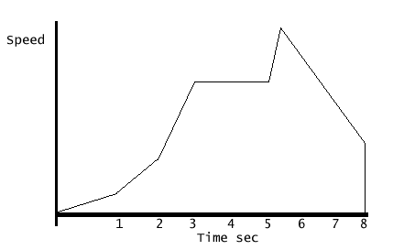

- Draw the speed-time graph of a model rocket.
The rocket accelerates skyward during the first 2 seconds of flight. As the fuel burns the thrust gets larger and larger. Its maximum speed is almost 30m/s. The fuel runs out after 2 seconds and the rocket starts to decelerate at a constant rate. 4 seconds after launch the rocket reaches its maximum height. It then starts to accelerate downwards and crashes 8 seconds after launch.
