Name:
Mark: /60

Science

Flight Work Book

Index

History of flight
Energy
Energy conversion during rocket flight
Flying in the atmosphere
Flying in Space
Escaping the atmosphere
Forces
Contact forces
Non contact forces
Balanced forces
Unbalanced forces
Acceleration
Forces during rocket flight
Motion graphs

Student Instructions

This is your workbook for the area of study of Flight.

The aim of this workbook is to assist you to work systematically through the concepts associated with Flight.

Before attempting to answer the questions in this work book we encourage you to read the section called Flight/ Outcomes on the Dynamic Science website. Naturally, you can also to look beyond this website for additional information.

Good luck and enjoy the discovery journey!

September 19 1783
Montgolfier brothers

November 21 1783
Montgolfier brothers

December 1783
Professor Jaques Charles

December 17 1903
Wright brothers

1926
Professor Robert Goddard

27 Aug 1939
Heinkel He 178

July 1944
Wernher Von Braun

1957
Sputnik

The history of flight

- The first hot air balloon to be flown

- First person to ascend in a hydrogen balloon

- The first liquid powered rocket is launched

- The first man-made satellite to orbit Earth is launched by the U.S.S.R.

- First astronaut to orbit the Earth

- The world’s first long range missile is launched

- First man to land on the moon

- First Shuttle flight

- First orbiting space station.

- The leading figure in NAZI Germany’s and the USA’s rocket programs

- First hot air balloon to transport people

- The flyer was the first plane to fly under its own power

- The first jet plane to fly

July 21 1969
Neil Armstrong

1981
Collumbia

Match the events on the right with the dates on the left. Place the appropriate number in the box next to the date.

April 12 1961
Yuri Gagarin

July 21 1969
Neil Armstrong

June 1971
Salyut

1981
Collumbia

Energy
"Energy can not be created or destroyed" This is called the law of conservation of energy. The amount of energy in the Universe is finite. Although we can not create energy we can change its form. For example burning wood changes the chemical energy, stored in the molecules of the wood, into heat and light energies.
This chemical energy originated as solar energy and converted into chemical potential energy by plants in a process called photosynthesis. In fact all the energy on Earth originated from the Sun!
We can not see energy, but we can recognize objects that contain it. Generally speaking, energy is the ability to move an object against an opposing force. It can also be described as the ability to do work.
Our world is full of every day examples where energy is transformed from one form into another. Energy can be put into objects to make them move (kinetic) or increase in temperature (heat energy). Examples of different forms of energy include:
-Chemical potential energy. This type of energy is stored in the form of chemicals. Food and petrol are examples of substances with chemical potential energy. The energy in the chemicals is released as heat to drive our cars and warm our bodies.
-Gravitational potential energy. This type of energy is stored in objects that are high off the ground. The higher off the ground and the heavier the object the more energy it possesses.
-Kinetic energy. Any moving object has kinetic energy. The faster an object travels the more kinetic energy it has. Also the heavier the object the more kinetic energy it has. An elephant travelling at 30km/hr can do more damage than a mouse travelling at the same speed. A mouse travelling at 10,000km/hr however, can impart more energy on impact than an elephant travelling at 1km/hr
Question: State 2 other types of energy you can think of
Answer:

(2 Marks)
Energy conversions during rocket flight (5 Marks)

Energy
The capacity to do work.

CP
KE
GP
HE

Peak altitude

Ready for launch

CP

KE

GP

HE

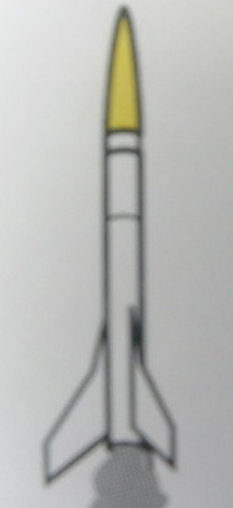

CP

KE

GP

HE

Boost phase

CP

KE

GP

HE

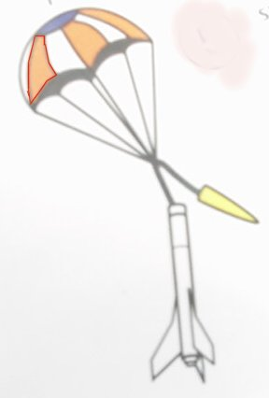

Coasting phase

CP

KE

GP

HE

CP = Chemical potential energy
KE = Kinetic energy
GP gravitational potential energy
HE = Heat energy

In Nature there is a law that states

“Energy can not be created or destroyed it can only be changed from one form into another” It is known as the law of conservation of energy.
Using the boxes next to each stage, explain what is happening to each energy form. Shade the appropriate box to indicate the level of the energy the rocket has. Use arrows to indicate if the energy type is increasing or decreasing.
For example, just prior to launch all the energy in the rocket is chemical potential energy in the form of fuel. During the next stage the chemical potential energy has decreased and the arrow indicates it is still decreasing. The BAR lines indicate no change.

Flying in the atmosphere
Flying through the atmosphere is very different to flying through space. We will explore some of the differences
The atmosphere behaves much like a fluid and for all intents and purposes is considered to be a fluid. A law which describes the effect of fluid flow is Bernoulli’s law (which originally described water flow). It states that
Fast flowing fluid creates an area of low pressure while slow moving fluid creates relative high pressure. This law was extended to air i.e.
Fast flowing air creates an area of low pressure while slow moving air creates a relative high pressure area.
(Note: Pressure can be viewed as force acting over an area.)
This characteristic of creating a pressure differential was exploited and incorporated into the design and construction of air plane wings. By creating an area on the wing that causes a low pressure and another area that causes a high pressure, on the opposite side of the wing, a net force can result i.e. if the low pressure is on the upper part of the wing and a relatively high pressure on the lower part of the wing, a lifting force results.

Refer to the diagram below to see the effect of a moving fluid (air) over a curved surface.
The wing is in great shape

Air is forced to flow quickly over the wing. Fast moving air creates an area of Lower Pressure. The area of low pressure SUCKS the wing upwards.

Air flowing at the bottom moves slower than the air at the top of the wing. Slow moving air creates higher pressure.

Question: Explain what would happen if the wings were turned upside down?
Answer:

___________________________________________________________

___________________________________________________________
(1 Mark)
Question: What type of vehicle uses this “upside down” wing arrangement and why?
Answer:

___________________________________________________________

___________________________________________________________
(1 Mark)

Flying in Space

Escaping the atmosphere

In order to escape from the atmosphere (and Earth’s gravity field) the Space shuttle initially needs a tremendous amount of thrust to lift off the ground.

Question: What two gases (compressed and cooled into liquid form) are mixed to provide the fuel used for liftoff?
Answer:

___________________________________________________________
(2 Marks)

A major difference between the atmosphere and space is that space is essentially a vacuum. This implies that there is no air in space hence there is no drag. Unfortunately there is also no gas to assist with combustion of fuels!

Question: State how these differences may affect the propulsion systems of jets vs. rockets i.e. explain the differences in environments, taking the atmosphere (or lack of it into account). Use Newton’s 3rd law and Bernoulli’s law to back your argument that the propulsion systems are different.

Answer:

___________________________________________________________

___________________________________________________________

___________________________________________________________

___________________________________________________________

___________________________________________________________
(5 Marks)

Forces

An unopposed force is a push or a pull that can cause an object to either:
- increase or decrease its speed
- change its direction
- change its shape.
If any of these things happen then a force must be acting on the object in question. Remember that a force has both a magnitude as well as a direction.

Forces can be divided into two categories, contact and non-contact.
Contact forces physically push or pull objects. Examples of such forces include:
-drag is a force that opposes the movement of objects through the air or water. It comes about due to molecules colliding with the surface of an object as it moves through air or water. The faster an object moves through air, the greater the drag force.
-thrust is created when gas or liquid is pushed, under great pressure, from the rear of an engine. It is also created by drive chains that change energy (internal to an engine) to forward moving forces e.g. a motor car engine.

-friction, which acts between two surfaces that slide over one another. This force opposes the movement of one surface over the other.
-lift is a force usually associated with aircraft. Lift is generated when air flows quickly over a curved surface.
-buoyancy is a force that we identify with boats and other sea vessels. This force comes about when an object displaces liquid that it is placed in. The greater the mass of the liquid displaced (pushed aside) the greater the force. This force acts upwards opposing the force of gravity.

Since air is considered to be a fluid, objects in the air also experience buoyant forces e.g. hot air balloons rise due to buoyancy. We will study this in more detail in another unit of work.

Non-contact forces are forces that are exerted over a distance i.e. you do not have to touch an object to exert these types of forces.

These include (amongst others) magnetic and electrostatic forces.

Question: What other non-contact forces can you think of? (Hint: it’s what keeps you from going into orbit!).

Answer:

___________________________________________________________

___________________________________________________________
(2 Marks)

Balanced Forces

Contact forces act in pairs. Many forces can act on an object at any one time. It is the sum of these forces that determines the net force applied to an object.

We often watch our gold fish at home and notice that they can float motionless for a few seconds. Since there is no acceleration, deceleration, change of direction or shape we can say that there is no net force acting on the gold fish. There are, however forces acting on it.

Question: These forces are equal in size and act in opposite directions. Name at least 2 forces acting on the gold fish

___________________________________________________________

___________________________________________________________
(2 Marks)

We can state that if the forces acting on an object are all balanced then its velocity (speed in a specific direction) will not change. This applies equally to stationary (zero velocity) and moving objects

If the forces acting on an object are not balanced, the object will tend to move in the direction of the resulting force and will experience a change in speed in a certain direction i.e the object will experience acceleration.

Consider a car cruising at a constant speed of 100km/hr along a country road. There does not seem to be any change in velocity. Are there forces acting on it? Yes of course there is but because there is no change in velocity there is no net force. When all forces acting on the vehicle are added, the result is zero force. Gravity is always acting to push the vehicle down but the road is pushing up with the same force. The engine is producing a force pushing the car forwards while drag and friction together oppose this force in the opposite direction.

Notice how the forces exerted on the vehicle act in pairs. Drag and friction act to oppose the forward thrust by the engine while the road pushes upwards to oppose the downward push of gravity.

Question: Consider a toy boat floating on the water. Buoyancy and gravity are acting on it. What can be said about these two forces acting on the boat?

Answer:

___________________________________________________________

___________________________________________________________
(2 Marks)

Bridges are structures that withstand huge forces due to gravity. Beams that form the structure of the bridge are either under compression or tension. Compressive forces squeeze the beams inwards while tensile forces stretch the beams outwards. The bridge is not moving so all forces acting on the bridge are balanced and the net force on the bridge is zero.

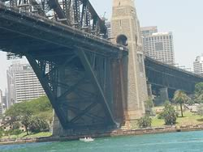

Unbalanced Forces

A F1-11 Fighter plane is accelerating skywards. Since it is accelerating, its speed is increasing, an unbalanced force must be acting on it.
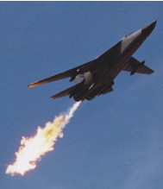

The forces acting on it include drag, lift, gravity and thrust. Obviously the plane is acted on by unbalanced forces. Since the plane is accelerating, the force of lift is greater than the force of gravity and thrust is greater than drag.

The racing car accelerates along a horizontal road surface. Once again unbalanced forces are acting on this vehicle. The forces acting on this vehicle include drag, friction, thrust from the engine, gravity and the push upwards by the road surface. Since the car accelerates the thrust produced by the engine is greater than the drag and friction forces acting on the vehicle. The road acts to push the car upwards with a force equal and opposite to the force of gravity pushing downwards.

Question: Fill in the missing words in the following paragraph:

The car described in the above paragraph will stop accelerating (but not come to a standstill) when the

________and _______________forces become large enough to balance the

thrust of the engine.
(2 Marks)

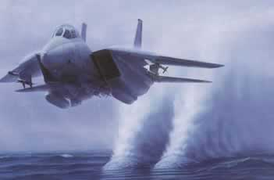

The Tomcat pictured above is accelerating horizontally close to the surface of the water.

Question: What forces are acting on this air plane in the horizontal plane and are they balanced?

Answer:
___________________________________________________________

___________________________________________________________
(2 Marks)

Question: Which are the balanced forces (in the vertical plane)?
Answer:

___________________________________________________________
(2 Marks)

Question: What happens to the force of drag as the plane slows down. Explain your answer?
Answer:

___________________________________________________________

(2 Marks)

A skydiver is descending at a slow constant speed. The drag forces are maximized by the parachute.

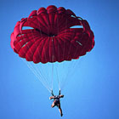

Question: State in which direction the drag and gravitational forces are acting respectively?
Answer:

___________________________________________________________
(2 Marks)

Question: If these forces are balanced, explain why the skydiver is still moving.
Answer:

___________________________________________________________
(1 Mark)

Question: State why you can you say that both of these forces are equal and act in opposite directions?
Answer:

___________________________________________________________
(2 Marks)

Acceleration and Force

What happens in the situations where you get unbalanced forces acting on an object? By our previous definitions, this means that the speed in a certain direction will be changing.

A definition of force is: F =ma

i.e. force is the product of a body’s mass and the acceleration it is experiencing.

The units of acceleration are metres per second, per second.
This means that the greater the acceleration the greater the force. An elephant accelerating at 10m/s/s will need greater force acting on it than a ping pong ball traveling with the same acceleration.
You can generally tell if a force is acting on an object because it will be accelerating or decelerating or changing direction.

What is acceleration?
Acceleration is the rate at which speed changes. In other words it is how fast the speed is changing.

We all experience acceleration due to gravity, of roughly 10 m/s/s.
This means that if we are free falling, every second our speed will increase by 10 m/s (within certain limits).

Question: What will your speed be after 4 seconds when you bungee jump off a cliff? (Assume you jump with an initial vertical speed of zero.)

Answer:

After 1 second your vertical speed will be 10 m/s

After 2 seconds you vertical speed will be 20 m/s

After 3 seconds you vertical speed will be _______ m/s

After 4 seconds you vertical speed will be _______m/s
(2 Marks)
___________________________________________________________

Forces that act on your model rocket before and during flight
Below is a diagram that indicates forces acting on your rocket at different times of its flight. Fill in the relative magnitudes and directions of the different forces using arrows as indicated. (5 Marks)

Force
That which changes a bodies state of rest or uniform motion in a straight line.

G
AF
DF
T

Peak altitude

G
AF
DF
T

Coasting phase

G = Gravity
AF = Parachute drag force
DF = Drag force
T = Thrust

G
AF
DF
T

Boost phase

G
AF
DF
T

Ready for launch

There are many forces acting on the model rocket during ascent. Thrust is the force pushing the rocket upwards and it must overcome the force of drag and gravity. Gravity is always present and Drag increases as the speed of the rocket increases. Once the engines are ignited the thrust produced quickly overwhelms drag and gravity and the rocket soars into the air.

G

AF

DF

T

Interpreting motion graphs

We can often visualize the relationship between distance, speed and acceleration with the aid graphs.

This is helpful in understanding when a net force is being applied to a body and when there is no net force being applied i.e. the body experiences a constant speed. (Remember, zero is also considered as a constant speed in a specific direction.)

Refer to the graph below
Speed
(km/hour)
Time (seconds)
55
45
5
35
25
20
10
10
Speed vs. time graph for an aircraft
(not drawn to scale)

As you can see from the graph, between 0 and 10 seconds the rocket’s speed is increasing at a steady rate (the rocket is speeding up with constant acceleration). How do we know the acceleration is constant? Look at the straight, sloping line from 0 to 10 seconds. The slope is constant between 0 to 10 seconds and therefore the acceleration is constant. (We can tell how strong the force is by looking at how steep the slope of the speed vs time graph is. The steeper the slope the greater the acceleration and therefore the force applied.)

Between 10 and 20 seconds the speed is constant. The rocket is not accelerating and so there is no force acting on the rocket.

Between 20 and 25 seconds constant deceleration is taking place. The force acting to slow the rocket down is more powerful than the force applied to the rocket between 0 and 10 seconds.

From 25 to 35 seconds, the rocket moves at a constant speed i.e. no change in speed hence no acceleration.

Between 35 and 45 seconds the rocket is accelerating at an increasing rate. The force applied during this period of time is continually getting bigger. This is indicated by the increasing slope of the curve.

Between 45 and 55 seconds, the rocket experiences a constant deceleration (hence the straight line) and comes to a standstill at 55 seconds.

Exercise in interpreting motion graphs
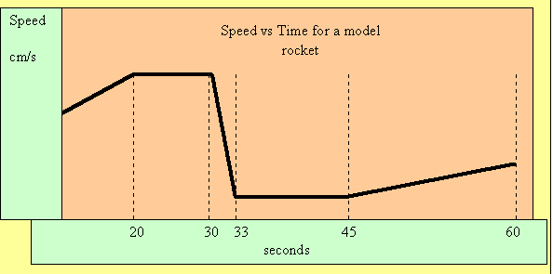
Acceleration is the rate at which speed is changing over time. Looking at a speed vs time graph, we can see where acceleration is occurring. At the points where the graph is sloping there is acceleration or deceleration. If the graph slopes as shown between 0 and 20 seconds acceleration is taking place. If the slope is as shown between 30 and 33 seconds deceleration is taking place.
The steeper the slope the faster the speed is changing and therefore the greater the acceleration or deceleration.
If the graph is straight, speed is constant and therefore acceleration is 0. In other words no change in speed is taking place.
Answer TRUE or FALSE for the following statements:
a) During 0 and 20 seconds the rocket is not accelerating.

b) During 20 and 30 seconds there is a massive deceleration that stops the rocket from moving.

c) The deceleration between 30 and 33 is greater in magnitude than the acceleration between 0 and 20 seconds.

d) The rocket is decelerating slowly between 45 and 60 seconds

e) There is no acceleration between 33 and 45 seconds.

(5 Marks)

