YEAR 11 CHEMISTRY TEST
Organic Chemistry Revision.

1) Define the following terms
a) Homologous series.

b) Isomer.

c) Saturated.

d) Unsaturated.

e) Alkane.

f) Alkene.

g) Alcohol.

h) Carboxylic acid.

i)Functional group.

18 marks

Use the definitions from the previous page appropriately in each row. The first one is done for you.
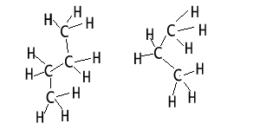 | Alkanes  Saturated  Homologous series.
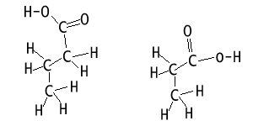
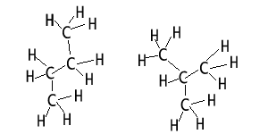
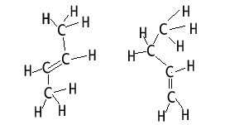
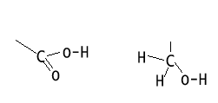

8 marks
2) Draw structural formulae for the following

2-methyl butane
2,2,-dimethyl butane
But-2-ene
3-ethyl pentane
Butanoic acid

Propanoic acid
Ethanoic acid
Propanol
Draw both isomers of propanol.

16 marks

3) Which of the following compounds listed in the table above are isomers of pentane?

2 marks
4) Place the following in order of increasing melting temperatures.
CH₃CH_{3 ,} CH₄ , CH₃ CH₂CH₂CH_{3,} CH₃CH₂CH₃

2 marks
5) Which pair of molecules has similar chemical properties? Explain
a) CH₂CH_{2,} CH₃CH₃
b) CH₃CH₂OH, HCOOH
c) CH₃CH₂OH, CH₃OH

2 marks
6) Methane, ethane and ethene are gases that have been mixed together. Describe a way to obtain pure samples of each.

2 marks

7) a) Describe the intermolecular and intramolecular bonding of:
i) Ethane;

ii) Ethanol;

iii) Ethanoic acid commonly known as acetic acid (vinegar);

iv) Ethene.

4 marks

b) Which of the compounds above are soluble in water? Explain why.

2 marks

c) Which hydrocarbon out of ethane and octane are liquid at room temperature? Explain?

1 marks

8) Complete the table below.
Compound | Dispersion forces present? | Hydrogen bonding present? | Soluble in water?
Methane
Octane
Ethanol
Butene

2 marks

9) Draw the structural formulae of all the isomers of butane.

2 marks

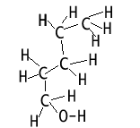

10) a) Consider pentanol, pictured on the right.
How many isomers does it have that can still be
be called pentanol ?

1 mark

b) Draw the structural formula of three of its isomers and name each isomer.

6 marks

11) Complete the table below. It consists of a number of reactions.
Compound 1 | Compound 2 | Name of product | Structural formula | Type of reaction
Ethanol | Ethanoic acid
Ethene | HCl
Ethene |  | Ethanol

9 marks

12) a) Draw the structural formula of a small section of the polymer formed from propene.

2 marks
b) Name and give the structural formula of the monomer that formed the polymer shown below.

CH₃ CH₃ CH₃ CH₃
| | | |
C – C – C – C – C – C – C –
2 marks

c) Draw the polymer structures in the box that best satisfy the properties mentioned
i) A low density, thermoplastic

ii) A high density, thermoplastic

iii) A thermosetting plastic

₆ marks
13) A hydrocarbon contains 85.7% by mass of carbon and its molar mass is between 68 and 74 g mol^{--.}
a) Calculate the empirical formula of the compound.

2 marks

b) Determine the molecular formula

1 mark
c) What homologous group does this compound belong to?
1 mark
d) Write a chemical equation for each of two reactions typical of this compound.

a)

b)

4 marks

