Name Teacher
YEAR 11 CHEMISTRY TEST
Organic chemistry

Name_____________________________ Teacher ___________________________
Section A answer sheet circle the correct response. Each question is worth 1 mark

1) A, B, C, D

2) A, B, C, D

3) A, B, C, D

4) A, B, C, D

5) A, B, C, D

6) A, B, C, D

7) A, B, C, D

8) A, B, C, D

9) A, B, C, D

10) A, B, C, D

11) A, B, C, D

12) A, B, C, D

13) A, B, C, D

14) A, B, C, D

15) A, B, C, D

16) A, B, C, D

17) A, B, C, D

18) A, B, C, D

19) A, B, C, D

20) A, B, C, D

Section B consists of 5 short answer questions. Write all answers in the space provided.

- Draw the structural formulae of the following compounds

1) Butane | 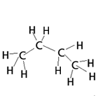
2) 2,3-dimethyl butane | 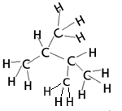
3) but-1-ene | 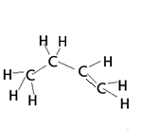
4) propanoic acid | 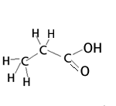
5) ethanol | 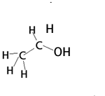
10 marks

2) Name the following compounds.
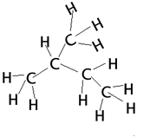 | 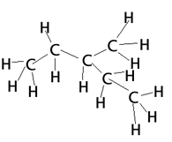
4 marks

2-methyl butane | 3-methyl pentane

3) The compound with molecular formula C₅H₁₂ has three isomers. Draw their structural formulae and name each isomer.
Name of isomer | Structural formula
Pentane
2-methylbutane
2,2-dimethylpropane
6 marks

4) Fill in the table below.
Name of compound | Intermolecular bonding | Intramolecular bonding | Is the molecule polar?
Ethane | Dispersion forces only. | Polar covalent | No
Propene | Dispersion forces only. | Polar covalent | No
Ethanol | Dispersion forces and hydrogen bonding | Polar covalent | Yes
Ethanoic acid | Dispersion forces and hydrogen bonding | Polar covalent | Yes
12 marks
5) a) Define the following terms and give one example for each.
-Homologous series.
A series of compounds with similar chemical properties in which each member in the series differs from the previous one by a –CH₂.
The alkanes are a homologous series. The first three members of this series are methane(CH₄), ethaneCH₃CH₃), propane(CH₃CH₂CH₃).
-Functional group
A group of atoms that give a molecule unique chemical properties. The carboxyl, COOH, functional group allows the molecule to act as a weak acid.
-Saturated hydrocarbon
Hydrocarbons that have only single carbon-carbon bonds. The alkane family of compounds are saturated hydrocarbons.

-Unsaturated hydrocarbon
Hydrocarbons that have at least one double or triple carbon-carbon bond. The alkene or alkyne family of compounds are unsaturated hydrocarbons.

8 marks

6) A hydrocarbon contains 85.7% by mass of carbon and its molar mass is between 50 and 60 g mol^{--.}
a) Calculate the empirical formula of the compound.

Step1 mass of C : H => 85.7g : 14.3g
Step2 mole 85.7/12 : 14.3/1
7.14 : 14.3
Step3 simplest mole ratio 1 : 2
Empirical formula CH₂

2 marks

b) Determine the molecular formula

Empirical mass is 14 if we multiple by 4 we get within the range of the molecular mass
So molecular formula is C₄H₈
1 mark
c) What homologous group does this compound belong to?
Alkene
- mark
    - Write a chemical equation for each of two reactions typical of this compound.

- Combustion reaction
C₄H₈(g) + 6O₂(g) => 4CO₂(g) + 4H₂O(g)

b) Addition reaction
4 marks
C₄H₈(g) + HCl(g) => C₄H₇Cl (g)

