Name Teacher
YEAR 11 CHEMISTRY TEST
Organic chemistry

- Which term best describes the molecule on the right?
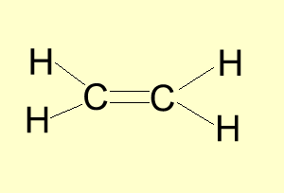

    - Saturated.
    - Unsaturated.
    - Alcohol.
    - Organic acid.

- Which of the following are members of the same homologous series

    - CH₄, C₃H₈, C₅H₁₂
    - CH₄, C₃H₆, C₅H₁₀
    - C₃H₈, C₅H₁₂, C₃H₆
    - CH₄, C₂H₂, C₅H₁₀

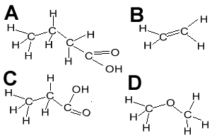
- Which one statement below is true?

    - Molecules “A” and “C” are isomers.
    - Molecules “B” and “D” belong to the same
homologous series.
    - Molecules “A” and “C” belong to the same
homologous series.
d) “B” is a saturated hydrocarbon.

- Ethanol, CH₃CH₂OH, is a liquid at room temperature whereas ethane, CH₃CH_{3,} is a gas. Which one statement below best describes why ethanol is a liquid?

    - Ethanol has strong covalent bonds and ethane does not.
    - Ethanol is a bigger molecule than ethane.
    - Hydrogen bonding exists between molecules of ethanol but not ethane.
    - Ethane has both dispersion forces and hydrogen bonding acting between its molecules while ethanol has dispersion forces only.

- Which of the molecules, pictured on the right, will produce
an acidic solution when dissolved in water?

    - Molecule “B” only.
    - Molecules “A” and “C” only.
    - Molecule “D” only.
    - Molecules “B” and “D” only.

- Consider the molecules pictured on the right. Which one of the
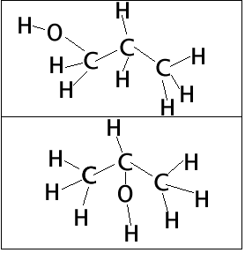
statements below is true?

    - Both molecules belong to the homologous series
of carboxylic acids.
    - The molecules are alkenes.
    - The molecules represent two different members
of the same homologous series.
    - The molecules are isomers.

- Which of the following belong to the same homologous series as ethene?

    - C₂H_{6,} C₃H₈.
    - C₄H_{8,} C₆H₁₂.
    - C₂H_{2,} C₃H₄.
    - CH₃CH₂CH₂OH, CH₃CH₂OH.
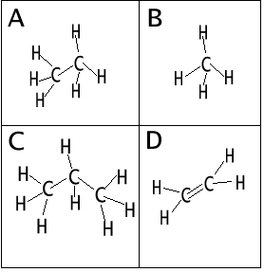

- Consider the molecules pictured on the right. Which one of the
following options places the molecules in order of increasing
melting temperature?

    - “A”, “B”, “C”, “D”.
    - “D”, “A”, “B”, “C”.
    - “B”, “D”, “A”,”C”.
    - “D”, “C”, “B”, “A”.

- Which of the following formulae represents an isomer of
CH₃CHCHCH₃?

    - CH₂CHCH₂CH₃
    - CH₂CHCH₂CH₂CH₃
    - CH₃CH₂CH₃
    - CH₃CH₂CH₂CH₃

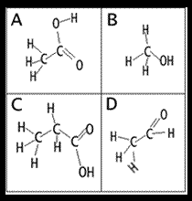
- Consider the molecules pictured on the right.
Which pair would you expect to have the most similar
properties?

    - A and C only.
    - B, C and D.
    - A, B, C and D because they are organic molecules.
    - D and B only.

- How many isomers exist for butene?

    - 1.
    - 2.
    - 3.
    - 4.
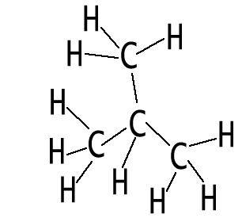

- Consider the molecule pictured on the right.
What is the name of this compound?

    - 2-ethyl propane.
    - 3-ethyl propane.
    - 2-methyl butane.
    - 2-methyl propane.

- Alkanes are also known as:

    - non-linear hydrocarbons;
    - tetrahedral hydrocarbons;
    - saturated hydrocarbons;
    - reactive hydrocarbons.

- An alkyne is characterised by a:

    - carbon-to-carbon single bond;
    - carbon-to-carbon triple bond;
    - carbon-to-oxygen double bond;
    - carbon-to-nitrogen triple bond.
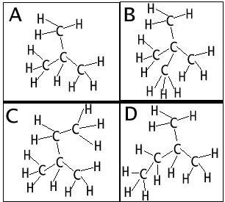
- Consider the structural formulae pictured on the right.
Which statement is true?

    - “D” is an isomer of butane.
    - Formula “B” represents 2,2,2-triethyl ethane.
    - Formula “A” represents 2-ethyl propane.
    - Formulae “C” and “D” are identical and represent
2-methyl butane.

- The diary of an organic chemist was found in his laboratory. The chemist was studying a group of compounds known as alkenes when he suddenly collapsed. The diary entry was incomplete and is shown here.”I have managed to isolate the compound hept……..”
Which statement is true?
    - The compound has 6 carbon atoms and one carbon-to-carbon double bond.
    - The compound contains 7 carbon-to-carbon double bonds.
    - The compound contains 7 carbon atoms and is likely to contain one or more carbon-to-carbon double bonds.
    - The compound has definitely 8 carbon atoms.

- Which name/s are not used to describe an isomer of pentene?
    - Pent-1-ene.
    - Pent-2-ene.
    - Pent-3-ene and Pent-4-ene.
    - Pent-1-ene and Pent-2-ene.

The table below refers to questions 18 and 19
Compound | Boiling temperature ºC
Methane | -161.5
Ethane | -88.6
Octane | 125.0
Pentane | 36.0
Butane | -0.5
Propane | -42.1

- Which compound is a gas at room temperature (25ºC)?
    - Butane.
    - Octane only.
    - Octane and pentane only.
    - Octane, ethane, propane and methane.

- The difference in boiling temperature between octane and ethane is due to:
    - differences in molecular shape;
    - differences in molecular size;
    - the presence of hydrogen bonding between octane molecules;
    - polar covalent bonds within the octane molecule.

- The name of the compound represented by the structural
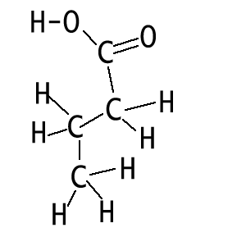
formula on the right is:
    - Propanol;
    - Propanoic acid;
    - Butanoic acid;
    - Pentanol.

Name_____________________________ Teacher ___________________________
Section A answer sheet. Ccircle the correct response. Each question is worth 1 mark

1) A, B, C, D

2) A, B, C, D

3) A, B, C, D

4) A, B, C, D

5) A, B, C, D

6) A, B, C, D

7) A, B, C, D

8) A, B, C, D

9) A, B, C, D

10) A, B, C, D

11) A, B, C, D

12) A, B, C, D

13) A, B, C, D

14) A, B, C, D

15) A, B, C, D

16) A, B, C, D

17) A, B, C, D

18) A, B, C, D

19) A, B, C, D

20) A, B, C, D
Section A = 20 marks /20
Section B = 44 marks /44

Total = 60 marks /64

Section B consists of 5 short answer questions. Write all answers in the space provided.

- Draw the structural formulae of the following compounds

1) Butane
2) 2,3-dimethyl butane
3) but-1-ene
4) propanoic acid
5) ethanol
10 marks
2) Name the following compounds.
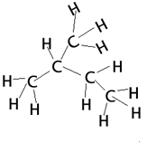 | 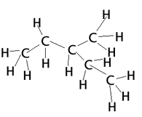
4 marks

3) The compound with molecular formula C₅H₁₂ has three isomers. Draw their structural formulae and name each isomer.
Name of isomer | Structural formula
6 marks
4) Fill in the table below.
Name of compound | Intermolecular bonding | Intramolecular bonding | Is the molecule polar?
Ethane
Propene
Ethanol
Ethanoic acid
12 marks
5) a) Define the following terms and give one example for each.
-Homologous series

-Functional group

-Saturated hydrocarbon

-Unsaturated hydrocarbon

8 marks
6) A hydrocarbon contains 85.7% by mass of carbon and its molar mass is between 50 and 60 g mol^{--.}
a) Calculate the empirical formula of the compound.

2 marks

b) Determine the molecular formula

1 mark
c) What homologous group does this compound belong to?
1 mark
    - Write a chemical equation for each of two reactions typical of this compound.

a)

b)
4 marks

