Solution to Q1
3H_{2(g)} + N_{2(g)}  2NH_{3(g)} ΔH = –91 kJ/mol

A mixture of hydrogen gas and nitrogen gas is placed in a reaction chamber and allowed to reach equilibrium. A number of events take place to disrupt the equilibrium. Complete the table below by circling the correct response. Compare the changes that occur between the initial equilibrium position and the final equilibrium position.

Action on the equilibrium | Equilibrium constant  Circle one of the options below | Mol H₂  when equilibrium is established | Mol N₂  when equilibrium is established | Mol NH₃  when equilibrium is established
Addition of NH₃ | No change  K can only change with a temperature change. | Increase  As the reaction proceeds in the backward direction | Increase  As the reaction proceeds in the backward direction | Increase  As the amount of NH₃ added is not all used up when the reaction proceeds in reverse.
The reaction chamber is doubled in volume | No change  K can only change with a temperature change. | Increase.  As the reaction proceeds in the backward direction to increase pressure | Increase.  As the reaction proceeds in the backward direction to increase pressure | Decrease.  As the reaction proceeds in the backward direction to increase pressure
The reaction vessel is heated | Decrease  As the reaction proceeds in the backward direction | Increase.  As the reaction proceeds in the backward direction to increase pressure | Increase.  As the reaction proceeds in the backward direction to increase pressure | Decrease.  As the reaction proceeds in the backward direction to increase pressure
The reaction vessel is cooled | Increase.  As the reaction proceeds in the forward direction | Decrease.  As the reaction proceeds in the forward direction | Decrease.  As the reaction proceeds in the forward direction | Increase.  As the reaction proceeds in the forward direction
Addition of H₂ | No change | Increase  As the amount of H₂ added is not all used up when the reaction proceeds in the forward direction | Decrease.  As the reaction proceeds in the forward direction | Increase.  As the reaction proceeds in the forward direction

20 marks

Question 2
The cells in the body produce carbon dioxide as a product of respiration. The equilibrium, between gaseous carbon dioxide and dissolved carbon dioxide, is established.
CO₂(g)  CO₂(aq)
Carbon dioxide dissolves in water to form the weak acid known as carbonic acid.
CO₂(aq) + H₂O(l)  H₂CO₃(aq)
Carbonic acid is in equilibrium with the hydrogen carbonate ion as shown in the second
H₂CO₃(aq) + H₂O(l)  HCO₃⁻(aq) + H₃O⁺(aq)
Air taken into the lungs has a very low concentration of carbon dioxide.
- What effect will hyperventilating (rapid breathing) have on the blood pH?
Hyperventilating reduces the amount of carbon dioxide in the lungs. This causes an equilibrium shift towards the production of more gaseous carbon dioxide and reduces the amount of dissolved carbon dioxide in the blood. The pH rises
1 mark
- Use Le Chatelier’s Principle to explain the changes in blood pH as blood travels from the tissues to the lungs.
Gaseous carbon dioxide is produced in the body as a product of respiration. In the tissues the equilibrium below shifts to the right.
CO₂(g)  CO₂(aq)
This in turn shifts the following equilibrium below to the right
CO₂(aq) + H₂O(l)  H₂CO₃(aq).
The pH of the blood in the tissues is lower than the blood pH in the lungs.
In the lungs the gaseous carbon dioxide is low and the following equilibrium shifts to the left
CO₂(g)  CO₂(aq).
As the concentration of dissolved carbon dioxide reduces, the equilibrium below shifts to the right.
CO₂(aq) + H₂O(l)  H₂CO₃(aq).
The pH of the blood in the lungs therefore increases.
- During a heart attack, blood stops circulating but the cells in the body continue to respire producing carbon dioxide. Before the heart is restarted doctors often inject a solution of sodium hydrogen carbonate(NaHCO₃) directly into the heart. Use Le Chatelier’s Principle to explain how this may effect the amount of carbon dioxide gas present in the tissues.
Adding NaHCO₃ will increase the pH of the tissue as the equilibrium below proceeds to the left
H₂CO₃(aq) + H₂O(l)  HCO₃⁻(aq) + H₃O⁺(aq)
Hence the following equilibrium CO₂(aq) + H₂O(l)  H₂CO₃(aq). moves to the left reducing H₃O⁺ ions and increasing the CO₂(aq)
d) Use Le Chatelier’s Principle to explain how blood pH will change if a person enters a room filled with carbon dioxide gas.
Carbon dioxide gas in the lungs will increase forcing the reaction below to shift to the right.
CO₂(g)  CO₂(aq)
Carbon dioxide dissolves in water to form the weak acid known as carbonic acid.
CO₂(aq) + H₂O(l)  H₂CO₃(aq)
As more carbonic acid is present the equation below will shift to the right creating more hydronium ions and decreasing the pH of the blood.
H₂CO₃(aq) + H₂O(l)  HCO₃⁻(aq) + H₃O⁺(aq)
2 mark
The reaction equation for the Haber process is given below.
N₂(g) + 3H₂(g)  2NH₃(g) ΔH = –91 kJ/mol

Question 3
2.80 grams of nitrogen gas reacts with 0.600 grams of hydrogen gas in a sealed 2.00 litre reaction vessel. After sometime equilibrium is reached at which point the amount of ammonia was found to be 0.170 grams.
- Calculate the equilibrium constant for the above reaction at the specified temperature.
Step 1 Find the mol of ammonia gas at equilibrium.
Mol of ammonia gas at equilibrium = 0.170 / 17 = 0.010 mol
Step 2 Find the mol of hydrogen and nitrogen gas that react
Mol of nitrogen reacted . According to the equation, for every 2 mol of ammonia formed 1 mol of nitrogen reacts. So for 0.010 mol of ammonia 0.005 of nitrogen reacts.
Mol of hydrogen reacted. According to the equation, for every 2 mol of ammonia formed 3 mol of hydrogen reacts. So for 0.010 mol of ammonia 0.015 mol of hydrogen reacts.
Step 3 Calculate the amount of hydrogen and nitrogen present at equilibrium.
Mol of nitrogen at equilibrium = mol of nitrogen before reaction – mol of nitrogen reacted.
= (2.80 / 28 ) - 0.005 = 0.10 – 0.005 = 0.095 mol
Mol of hydrogen at equilibrium = mol of hydrogen before reaction – mol of hydrogen reacted.
= (0.600 / 2.0 ) – 0.015 = 0.30 – 0.015 = 0.285
Step 4 Calculate the concentration of gas present.
[Ammonia] = 0.010 / 2.00 = 0.00500 M
[hydrogen] = 0.285 / 2.00 = 0.145 M
[nitrogen] = 0.095 / 2.00 = 0.048 M

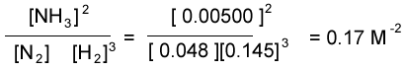

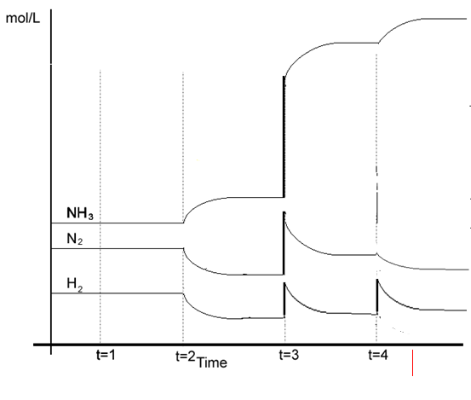

- On the set of axis above sketch the concentration changes of the system when at :
    - T=1 helium gas is added to the system to increase the pressure and equilibrium is achieved before T=2.

ii) T =2 the reaction vessel is cooled and equilibrium is achieved before T=3.

- T =3 the volume of the reaction vessel is halved and equilibrium is achieved before T=4.

iv) T =4 hydrogen gas is injected into the reaction vessel.
4 marks

Solution to Question 4

The reaction equation below describes the equilibrium that exists between the Fe³⁺(aq) cation, the SCN¹⁻(aq) anion, and the complex ion Fe(SCN)²⁺(aq).

Fe³⁺(aq) + SCN¹⁻(aq)  Fe(SCN)²⁺(aq)

The Fe³⁺(aq) is a pale yellow colour and complex the Fe(SCN)²⁺(aq) ion is a red colour.

To a pale yellow solution of the Fe³⁺(aq) ions:

Action on the equilibrium | Expected colour change  Circle the appropriate response
Potassium thiocyanate (KSCN) solution is slowly added | The solution turns from pale yellow to reddish  Fe³⁺(aq) + SCN¹⁻(aq)  Fe(SCN)²⁺(aq)  Addition of SCN⁻ will drive the reaction above to the right, increasing the reddish colour of the solution
To the resulting solution iron(III)nitrate is added. | The solution turns from a reddish to a deeper red  Fe³⁺(aq) + SCN¹⁻(aq)  Fe(SCN)²⁺(aq)  Addition of Fe³⁺ will drive the reaction above to the right, increasing the reddish colour of the solution
The resulting solution is now left overnight so that water evaporates and the volume of the original solution is halved. | The solution turns from a reddish to a deeper red  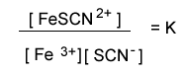  Reducing the volume increases the concentration. The value of the equilibrium expression is reduced and the system moves to the right to increase the value of the equilibrium expression to its constant value K. Another way of looking at the system is that an increase in concentration is opposed by moving in the direction of least molecules.
A catalyst is added to the solution above. | The colour of the solution remains unchanged  Catalysts have no effect on the position of the equilibrium. A catalyst speeds both the forward and backward reactions simultaneously.

Question 5
Consider the following systems in the table below. If each system is at equilibrium predict what effect the stated action will have on K and the mol of reactants present when the system is allowed to reach equilibrium once more.
Circle the appropriate response in the table below.

Equilibrium system | Action | Change in K | Change in the mol of reactant
H_{2(g)} + I_{2(g)} => 2HI_{(g)} | Volume is doubled | Unchanged | Unchanged  Equal number of molecules exist on both sides
H_{2(g)} + I_{2(g)} => 2HI_{(g)} | Helium gas is added at constant volume | Unchanged | Unchanged  He is an inert gas. No change to the concentration of species takes place.
2C₄H_{10(g)} + 13O_{2(g)} => 8CO_{2(g)} + 10H₂O_{(l)} ΔH = –91 kJ/mol | The reaction vessel is heated | Decrease | Increase  Input of heat energy drives the exothermic reaction in reverse
2SO_{2(g)} + O_{2(g)} => 2SO_{3(g)} | Volume is doubled | Unchanged | Increase
CH_{4(g)} + 2O_{2(g)} => CO_{2(g)} + H₂O_{(g)} −ΔH kJ/mol | The reaction chamber is cooled. | Increased | Decreased

10 marks

Solution to Question 6
Nitrogen gas and hydrogen gas react in a 2 L sealed vessel according to the following equation.
N₂(g) + 3H₂(g)  2NH₃(g)
The system is allowed to reach equilibrium and the equilibrium constant calculated at 4.00 M⁻². Analysis shows that twice as many mol of hydrogen are present than mol of nitrogen. While the same number of mol of ammonia and hydrogen gas exist.
Calculate the mass of nitrogen, hydrogen and ammonia at equilibrium.
Atomic mass N =14.0, H = 1.01

Step 1 Write the equilibrium expression
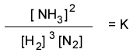
Step 2 Let x be the number of mol of nitrogen.
So Mol of nitrogen = x
Mol of hydrogen = 2x
Mol of ammonia = 2x
Step 3 Find x
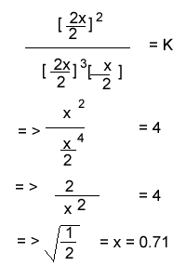
Step 4 Find the mass of each species
Nitrogen = mol X formula mass = 0.71 X 28 = 20 grams
Hydrogen = mol X formula mass = 1.42 X 2 = 2.8 grams
Ammonia = mol X formula mass = 1.42 X 17 = 24.1 grams

Question 7
Phosgene gas is a known toxin used in chemical warfare, It is produced according to the equation below.
CO(g) + Cl₂ (g)  COCl₂ (g) ΔH = ?kJ/mol.
This gas (COCl₂) quickly decomposes when strongly heated to CO and Cl₂ gases.
- According to the information given suggest whether the synthesis of phosgene is an exothermic or endothermic reaction. Give reasons.
It is exothermic. Increase in temperature drives the backward reaction to form CO and Cl₂
- At a given temperature of 100ºC the reaction below has an equilibrium constant,
K_{c} = 2.20 X 10⁻¹⁰ M.
COCl₂ (g)  CO(g) + Cl₂ (g)
If 0.100 mol of phosgene, COCl₂, is placed in a 1.00 L sealed vessel, calculate the concentration of carbon monoxide at equilibrium.
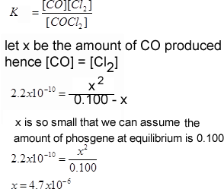
3 marks

- What can you say about the amount of phosgene gas produced at 100ºC. Explain
Kc for the reaction COCl₂ (g)  CO(g) + Cl₂ (g) is 2.2 X 10⁻¹⁰ this is very low indeed. Kc for the formation of phosgene, however, COCl₂ (g)  CO(g) + Cl₂, is 1/ 2.2 X 10⁻¹⁰ or 4.5 X 10⁹ which is very high. Hence the reaction at 100ºC is negligible to produce phosgene will go far to the right producing a great deal of phosgene.
1 mark

Question 8
When carbon monoxide binds to hemoglobin it forms bonds that are, roughly, 300 times stronger than the bonds formed between hemoglobin and oxygen. As a consequence the equilibrium constant for the formation of carboxyhemoglobin, according to the equation Hb (aq) + 4CO (g) ⇋ Hb(CO) ₄ (aq) is much higher than for the hemoglobin-oxygen reaction Hb (aq) + 4O ₂ (g) ⇋ Hb(O ₂ ) ₄ (aq).
Hemoglobin that is bound to carbon monoxide is no longer available to bind oxygen and this can cause asphyxiation in organisms. Treatment of carbon monoxide poisoning involves the use of a hyperbaric chamber to drive the reaction below.
Hb(CO) ₄ (aq) + 4O₂ (g) ⇋ Hb(O ₂ ) ₄ (aq) + 4CO (g).
Explain, using Le Chatelier's, how
hyperbaric chamber can treat
carbon monoxide poisoning.
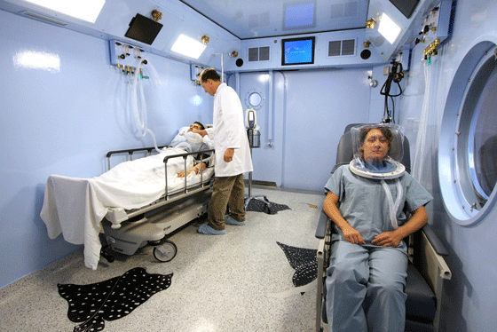

By increasing the pressure of
oxygen gas we drive the Hb(CO) ₄ (aq) + 4O₂ (g) ⇋ Hb(O ₂ ) ₄ (aq) + 4CO (g).to the right hence increasing Hb(O ₂ ) ₄ (aq).

